Policy Name | GAUS Research Framework
Proposed By | Director ORIC
Reviewed By | Registrar and Pro-VC
Approved By | ORIC Steering Committee
Effective From | 01-07-2026
Next Review Date | 30-06-2028
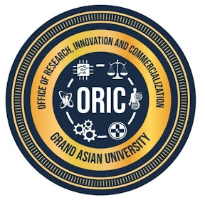
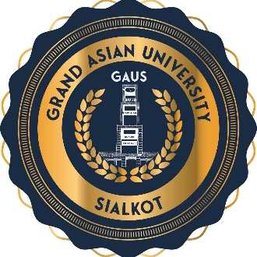
- Preamble
Grand Asian University Sialkot recognizes research as a cornerstone of excellence, innovation, and sustainable development. The University is committed to fostering a research culture that promotes creativity, critical inquiry, interdisciplinary collaboration, and ethical scholarship. This policy establishes an institutional framework for planning, conducting, supporting, and contributing to scientific advancement, industrial innovation, public policy, and societal well-being.
- Purpose
This policy provides a comprehensive framework to promote high-quality research, strengthen research governance, encourage innovation, facilitate external funding, protect intellectual property, and establish Grand Asian University as a internationally recognized research-intensive institution.
- Vision
To position Grand Asian University Sialkot as a leading center of research, innovation, entrepreneurship, and commercialization, delivering sustainable solutions that advance industry, society and global development.
- Mission
To strengthen Grand Asian University’s research ecosystem by enabling high quality research, fostering industry-academia partnerships, supporting intellectual property development, and driving knowledge commercialization – translating innovation into sustainable societal and economic impact.
- Scope
This policy applies to all faculty members, researchers, students, research staff, research centers, laboratories, and collaborative research activities conducted under the auspices of Islam group and Grand Asian University.

- Policy Statement
Grand Asian University shall promote a culture of excellence in research by supporting high-quality scholarly activities, ensuring research integrity, encouraging interdisciplinary collaboration, strengthening industry-academia partnerships, securing competitive research funding, and translating research outcomes into societal and economic impact.
- Institutional Research Philosophy
Research at Grand Asian University shall be driven by excellence, integrity, innovation, and impact. The University believes that research should generate knowledge, solve real-world problems, strengthen industry, influence policy, and improve the quality of life.
- Research Governance Framework
Research activities shall be governed through a structured framework comprising the Institutional Review Board (IRB), Directorate/Board of Advanced Studies and Research (DASR/BASR), Departmental Research and Review Committee (DRRC), Faculties, Research Centers, and Principal Investigators. ORIC shall coordinate institutional research planning, monitoring, and reporting.
- Institutional Research Priorities
The University shall prioritize align its research with institutional strengths, national priorities, industry needs, and the Sustainable Development Goals. Priority areas may include Artificial Intelligence, Biotechnology, Biochemistry, Health Sciences, Entrepreneurship, Agriculture, Chemical technology, Mathematical applications, Climate Change, Digital Transformation, Business Innovation, and Social Development.
- Roles and Responsibilities
The University shall provide strategic leadership and research infrastructure. ORIC shall facilitate research management, grant administration, commercialization, and partnerships. Faculty members shall conduct quality research, supervise students, seek research funding, and uphold research integrity. Students shall actively participate in ethical and responsible research.
- Research Funding Framework
The University shall promote internal seed funding, external competitive grants, industry-sponsored research, consultancy projects, philanthropic funding, and international collaborations to diversify research funding sources.
- Research Ethics and Integrity
All research shall comply with the highest standards of ethics, integrity, transparency, and responsible conduct. Research involving human participants, animals, or sensitive data shall receive prior approval from the Institutional Review Board and comply with applicable ethical guidelines.
- Research Capacity Development
The University shall continuously strengthen research capacity through faculty development programs, grant writing workshops, research methodology training, postgraduate supervision, mentoring, international collaborations, and researcher mobility initiatives.
- Research Incentives and Recognition
The University shall recognize outstanding research achievements through performance-based incentives, research awards, publication support, patent incentives, commercialization rewards, and recognition of excellence in research supervision and innovation.
- Intellectual Property and Commercialization
The University shall protect intellectual property generated through research and facilitate its commercialization through patents, licensing, technology transfer, startup development, and industry partnerships in accordance with the University's Intellectual Property Policy.
- National and International Collaboration
The University shall promote national and international research collaboration through joint research projects, faculty and student exchanges, international funding opportunities, visiting scholars, and strategic partnerships with leading universities and research organizations. The University shall strengthen collaboration with industry through contract research, consultancy, internships, technology transfer, collaborative innovation, and commercialization of research outcomes to address industrial and societal challenges.
- Digital Research Transformation
The University shall leverage digital technologies, artificial intelligence, research information systems, data analytics, and open science platforms to enhance research productivity, collaboration, transparency, and global visibility.
- Policy Review and Amendments
This policy should be reviewed every two years, or earlier if required, to ensure alignment with the University's strategic priorities, HEC regulations, emerging technologies, and best international practices. Amendments shall be approved by the appropriate statutory bodies of the University.

Proposed By: Approved By:

Director ORIC Vice Chancellor/ Chairman ORIC-SC
Grand Asian University Sialkot Grand Asian University Sialkot

